**EXPERIMENT NO.5**

AIM: To design an 8×1 Multiplexer.

IC USED: 7486(X-OR), 7408(AND), 7432(OR), 7404(NOT), 74151A (8×1 MUX).

THEORY: A multiplexer is a device that performs multiplexing i.e. it selects one of many analog or digital input signals and forwards the selected input into a single line. A multiplexer of 2n inputs has n select lines, which are used to select which input line to be sent to the output.

A Boolean equation for 8×1 Multiplexer is

Z = A’.B’.C’ + A’.B’.C + A’.B.C’ + A’.B.C + A.B’.C’ + A.B’.C + A.B.C’ + A.B.C

|  |
| --- |

TRUTH TABLE:

| **S0** | **S1** | **S2** | **Z** |
| --- | --- | --- | --- |
| 0 | 0 | 0 | A |
| 0 | 0 | 1 | B |
| 0 | 1 | 0 | C |
| 0 | 1 | 1 | D |
| 1 | 0 | 0 | E |
| 1 | 0 | 1 | F |
| 1 | 1 | 0 | G |
| 1 | 1 | 1 | H |

SCHEMATIC DIAGRAM:

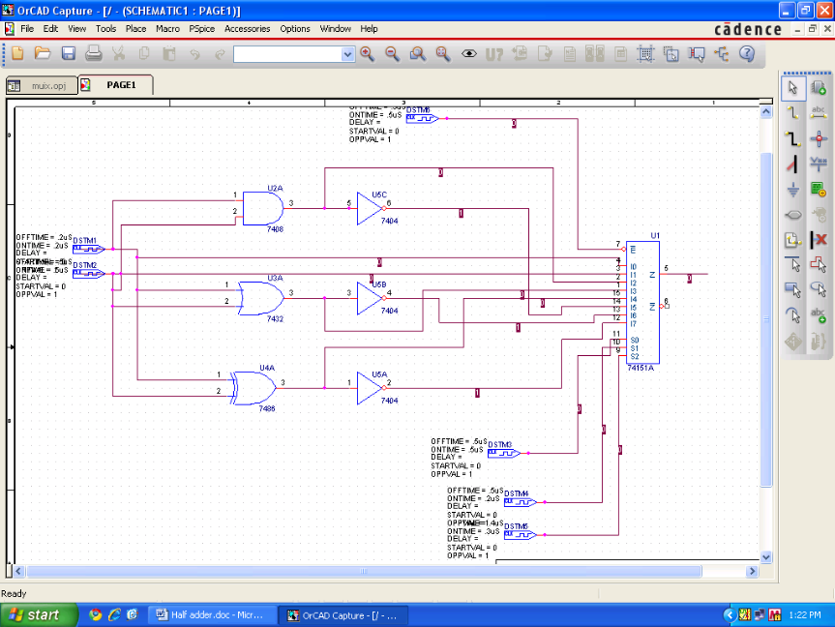

WAVEFORM:

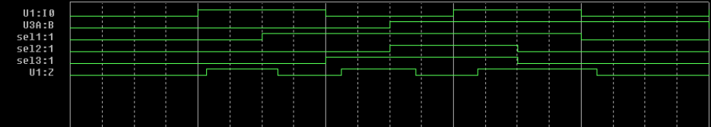

RESULT: The output waveform of 8×1 Multiplexer is verified.